Task
Look at the following diagram. Some of the angles have been marked.
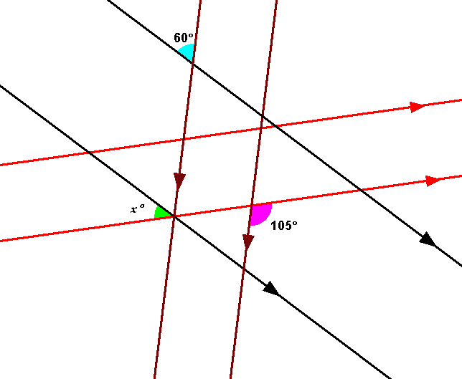
Do you think that you have been given enough information to enable you to calculate the size of angle x using angle properties that you know?
Make a list of the angle properties that you might need.

Use the diagram and the angle properties given to identify some of the missing angles.
Use this information to calculate the size of angle x.
Which angle properties did you use?

